Harrison Leggio

CSC 212

**FINAL PROGRAM: USER MANUAL**

Upon running the program, the user will be presented with the GUI. Firstly, I will describe all aspects of the GUI, and will later discuss what the functions of each part are, and lastly what is going on behind the scenes.

The program has 5 buttons. The buttons are as follows:

* Throw: adds a new ball into the window
* Remove: removes the last ball added into the window
* Faster: speeds up all the balls in the window
* Slower: slows down all the balls in the window
* 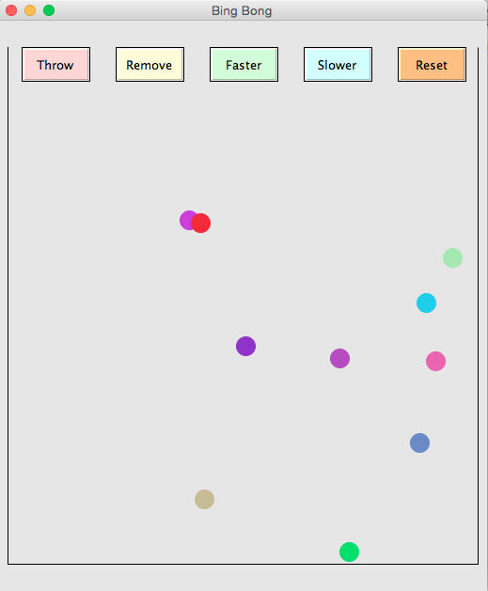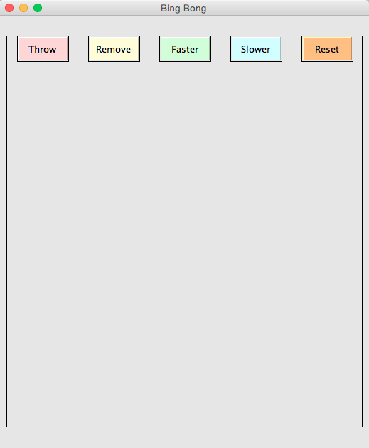Reset: resets the window to it’s original state

The next thing you may notice are the 3 walls of the window. These serve as boundaries. The balls are trapped within these walls, and cannot escape them. There is however, no wall on the top of the window. The balls are free to bounce out of view, only to return back into the window. All of the balls follow the gravitation laws. When a ball hits the wall, it will bounce back in the appropriate direction. When a ball hits another ball, it will also bounce back in the appropriate direction. This can be visible in the 2 ball collision detection methods, go hand in hand, which I will later describe in further detail. When the faster and slower buttons are clicked, the interval at which the timer “ticks” is either increased or decreased.

There are 3 collision detection methods in this program. As I previously stated, they work together. The first collision detection method has to do with the balls hitting the window boundaries. The other however, is slightly more complicated. The first ball collision method lies within the Ball class. This method actually handles physics behind the ball collision. In a nutshell, this method just negates the X and Y velocity if a ball “touches” another ball. By touching I mean if the balls X and Y coordinates overlap. The second method can be found in the Collection class. This method will loop through and pick a ball, then pick the next ball, compare to see if it collides, get the next ball, see if it collides, and so on and so forth until it reaches the end of the linked list. Basically, only 2 balls are checked at a time, meaning this method is constantly passing 2 balls to the collision method in the Ball class to check.